# **THE SAFEST PATH**

|  |  |  |  |
| --- | --- | --- | --- |
| Nicolás Moreno López  Universidad Eafit  Colombia  nmorenol1@eafit.edu.co | Luciana Pineda Yepes  Universidad Eafit  Colombia  lpineday@eafit.edu.co | Andrea Serna Universidad Eafit Colombia asernac1@eafit.edu.co | Mauricio Toro  Universidad Eafit  Colombia  mtorobe@eafit.edu.co |

# **ABSTRACT**

The principal problem is street sexual harassment. This problem is important because there are a lot of cases of this issue and especially women are seriously affected, even to the point of changing their way of dressing. Other issues related to harassment can be dangerous routes, sexual harassment in several places, and insecurity in the streets, which can result in robberies and deaths.

## **Keywords**

|  |
| --- |
| Constrainted shortest path, street sexual harassment,  secure-path identification, crime prevention. |

# **1. INTRODUCTION**

Women’s safety is the principal motivation for the reason that a lot of women feel insecure and have fear of walking alone or transit for some places where they can be harassed or even outraged, something that happens every day against thousands and thousands of women. Colombian prosecutor’s office has expressed that from just 4 complaints they got in 2008, then were more than 1.656 complaints. They also said that the number of harassment cases was 11.098 in January of 2018.

# **1.1. Problem**

In a few words, explain the problem, the impact that this problem has in society and why it is useful to solve this problem. *(In this semester, the problem is to calculate the shortest path without exceeding a weighted-average risk of harassment r and the path with lowest weighted-average risk of harassment without exceeding a distance d).*

**1.3 Article structure**

In what follows, in Section 2, we present related work to the problem. Later, in Section 3, we present the data sets and methods used in this research. In Section 4, we present the algorithm design. After, in Section 5, we present the results. Finally, in Section 6, we discuss the results and we propose some future work directions.

**2. RELATED WORK**

## In what follows, we explain four related works to path finding to prevent street sexual harassment and crime in general.

## Explain four (4) articles related to the problem described in Section 1.1. You may find the related problems in scientific journals. Consider Google Scholar for your search. *(In this semester, related work is path finding implementations to prevent street sexual-harassment and crime in general).*

## **3.1 Write a title for the first related problem**

You should mention the problem they solved, the algorithm they used, the results they obtained, and the ACM citation.

## **3.2 Write a title for the second related problem**

You should mention the problem they solved, the algorithm they used, the results they obtained, and the ACM citation.

## **3.3 Write a title for the third related problem**

You should mention the problem they solved, the algorithm they used, the results they obtained, and the ACM citation.

## **3.4 Wite a title for the fourth related problem**

You should mention the problem they solved, the algorithm they used, the results they obtained, and the ACM citation.

## **3. MATERIALS AND METHODS**

In this section, we explain how data was collected and processed and, after, different constrained shortest-path algorithm alternatives to tackle street sexual-harassment.

## **3.1 Data Collection and Processing**

The map of Medellín was obtained from Open Street Maps (OSM)[1] and downloaded using Python OSMnx API[2]. The (i) length of each segment, in meters; (2) indication wheter the segment is one way or not, and (3) well-known binary representation of geometries were obtained from metadata provided by OSM.

For this project, we calculated the linear combination that captures the maximum variance between (i) the fraction of households that feel insecure and (ii) the fraction of households with income below one minimum wage. These data were obtained from the quality of life survey, Medellín, 2017. The linear combination was normalized, using the maximum and minimum, to obtain values between 0 to 1. The linear combination was obtained using principal components analysis. The risk of harassment is defined as one minus the normalized linear combination. Figure 1 presents the risk of harrament calculated. Map is available at Github[3].

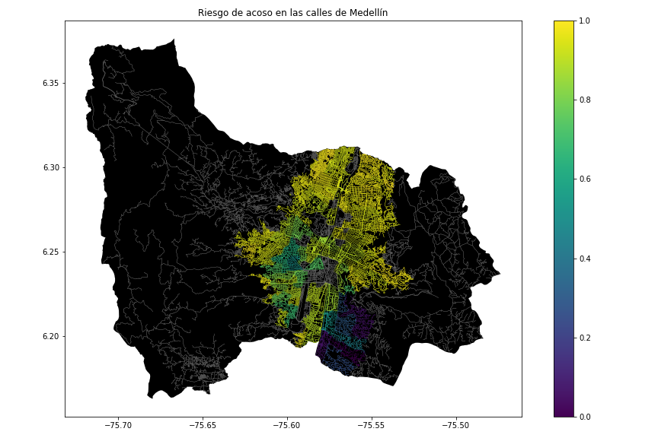**Figure 1.** Risk of sexual harassment calculated as a lineal combination of the fraction of households that feel insecure and the fraction of households with income below one minimum wage, obtained from Life Quality Survey of Medellín, in 2017.

## **3.2 Constrained Shortest-Path Alternatives**

## In what follows, we present different algorithms used for constrained shortest path.

**3.2.1 Bellman-Ford Algorithm**

[1] It is similar to Dijkstra's algorithm but it can work with graphs in which edges can have negative weights.

The Bellman-Ford algorithm works to find the shortest path between a given node and all other nodes in the graph. Though it is slower than the other algorithms. It’s important to note that if there is a negative cycle – in which the edges sum to a negative value – in the graph, then there is no shortest or cheapest path. Meaning the algorithm is prevented from being able to find the correct route since it terminates on a negative cycle. Bellman-Ford can detect negative cycles and report on their existence.

**3.2.2 Floyd-Warshall Algorithm**

The Floyd-Warshall stands out in that unlike the previous two algorithms it is not a single-source algorithm. Meaning, it calculates the shortest distance between every pair of nodes in the graph, rather than only calculating from a single node. It works by breaking the main problem into smaller ones, then combining the answers to solve the main shortest path issue. [2] This algorithm works for both the directed and undirected weighted graphs. But, it does not work for the graphs with negative cycles.

Floyd-Warshall is extremely useful when it comes to generating routes for multi-stop trips as it calculates the shortest path between all the relevant nodes. For this reason, many route planning software will utilize this algorithm as it will provide you with the most optimized route from any given location. Therefore, no matter where you currently are, Floyd-Warshall will determine the fastest way to get to any other node on the graph.

**3.2.3 Johnson’s Algorithm**

Johnson’s algorithm works best with sparse graphs, the fewer edges, the faster it will generate a route, as its runtime depends on the number of edges.

This algorithm relies on two other algorithms to determine the shortest path. First, it uses Bellman-Ford to detect negative cycles and eliminate any negative edges. Then use Dijkstra’s algorithm to calculate the shortest paths in the original graph that was inputted.

[3] The idea of Johnson’s algorithm is to re-weight all edges and make them all positive, then apply Dijkstra’s algorithm for every vertex.

**3.2.4 Prim's Algorithm**

Prim's algorithm of finds a minimum spanning tree for a weighted undirected graph. This means it finds a subset of the edges that forms a tree that includes every vertex, where the total weight of all the edges in the tree is minimized. But can't find MS Forest like Krushkal's Algorithm does.

[4] Kruskal's algorithm is another popular minimum spanning tree algorithm that uses a different logic to find the MST of a graph.

**The complexity of all algorithms.**

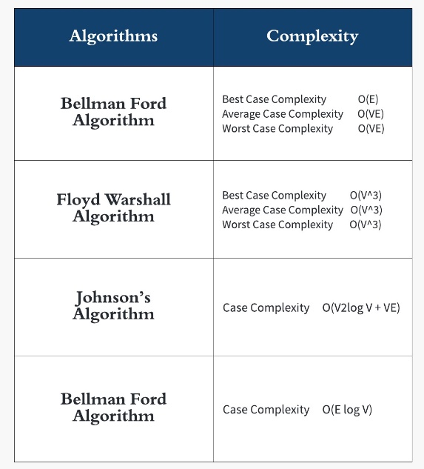

**4.2 Algorithms**

In this work, we propose algorithms for the constrained shortest-path problem. The first algorithm calculates the shortest path without exceeding a weighted-average risk of harassment *r*. The second algorithm calculates the path with the lowest weighted-average risk of harassment without exceeding a distance *d*.

.

# **REFERENCES**

https://www.revistalevel.com.co/contenido/el-acoso-callejero-a-las-mujeres-en-colombia-mas-penas-o-mas-educacion

1. <https://www.openstreetmap.org/>
2. https://osmnx.readthedocs.io/
3. [https://github.com/mauriciotoro/ST0245Eafit/tree/master/  
   proyecto/Datasets](https://github.com/mauriciotoro/ST0245Eafit/tree/master/proyecto/Datasets)/